# Software Project Management and Quality Assurance

## Practical – 7

Exploring Risk Management from the Software Project Management Software:

**Project Manager:**

We can use this website basically for risk management. It provides other basic functionality which others might provide along with risk management.

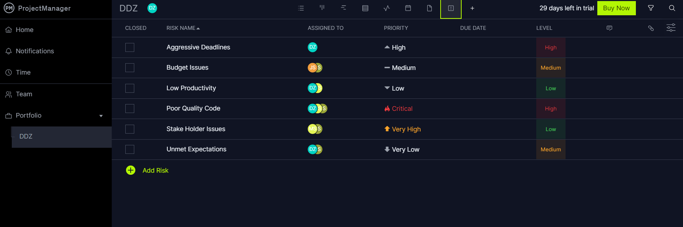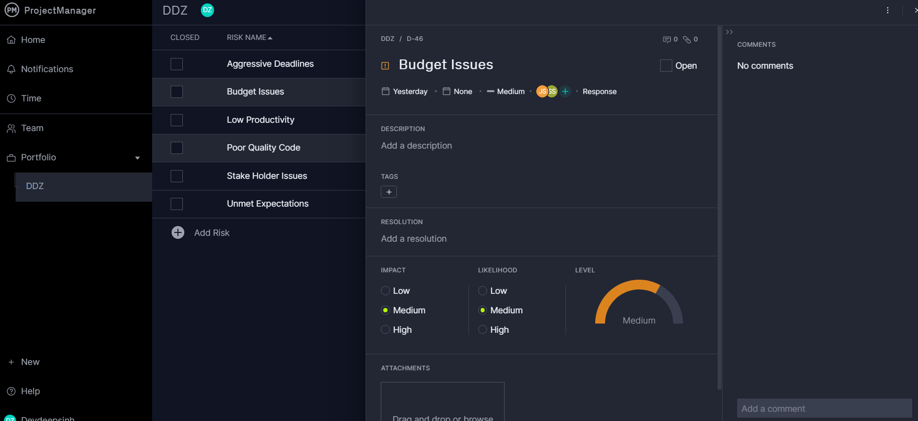

Project Dashboard:

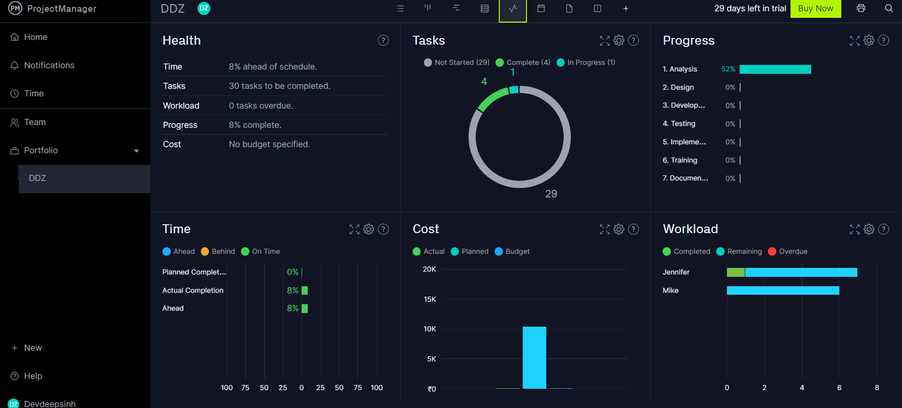

References:

https://software.projectmanager.com/project/risk/D